Final Project Report

1. Introduction
1.1. Project Overview
The continuous integration of smartphones into everyday environments has triggered widespread concerns regarding user mental health and cognitive burnout. This project delivers an end-to-end data processing, analytics, and business intelligence system designed to track device engagement. By isolating behavioral metrics across diverse user profiles, this solution shifts digital wellness monitoring from passive tracking to active intervention planning.
1.2. Objectives
- Trends Over Time Analysis: Pinpoint hourly spikes, weekend usage deviations, and late-night scrolling habits via device pickups and alerts.
- Performance & Category Mapping: Compare continuous user presence across varying application spaces (Social Media, Gaming, Productivity).
- Demographic Cohort Assessment: Identify vulnerability segments to build tailored wellness features.
- Goal Achievement Measurement: Evaluate ongoing compliance metrics against target sleep windows and downtime rules.
2. Project Initialization and Planning Phase
2.1. Define Problem Statement
Excessive smartphone interaction results in severe psychological friction, screen dependency loops, and circadian rhythm disruption. Current interface elements often apply invasive notification schemas that trigger continuous, involuntary device checking. Without clear visual aggregation, users remain unaware of chronic threshold violations and active time decay across non-productive apps.
2.2. Project Proposal (Proposed Solution)
The proposed solution implements a Power BI business intelligence interface to visually track user behavioral telemetry. By ingesting metrics related to device pickups, app categories, and session overruns, the system flags high-risk profiles in real-time. This provides clear behavioral feedback and evaluates whether feature packages like Focus Mode improve digital wellness scores.
2.3. Initial Project Planning
The project layout follows a smooth, step-by-step setup to turn raw mobile data into clear charts:
- Planning the Setup: The first stage focuses on finding out what data is needed to track smartphone habits, designing the main data tables, and setting up the basic data pipelines.
- Preparing the Data: The next stage moves into cleaning up the mobile tracking data, removing mistakes or duplicate logs, loading the clean datasets, and linking the tables together so they can talk to each other.
- Building the Dashboard: The final stage focuses on creating simple user group charts (like tracking screen limits by age or gender), testing the dashboard to make sure it loads quickly, and launching the final interactive screens.

3. Data Collection and Preprocessing Phase
3.1. Data Collection Plan and Raw Data Sources Identified
Data was collected across a multi-platform telemetry infrastructure monitoring Android and iOS mobile spaces. Raw log metrics include:
- Demographics: Age group buckets, active user status, and gender flags.
- Usage Quantifiers: Continuous session hours, device pickups, and raw notification volumes.
- Wellness Signals: System-driven intervention alerts, Focus Mode session counts, and subjective user well-being responses.
3.2. Data Quality Report
An inspection of the raw records showed high data integrity with minor data quality considerations:
- Missing Value Anomalies: Incomplete text fields within self-reported well-being ratings were identified and resolved.
- Duplicate Entries: Overlapping telemetry pings from multi-device users were isolated and removed to prevent double-counting.
- Schema Uniformity: Text indicators across different mobile platforms were normalized to create consistent categorical values.
3.3. Data Exploration and Preprocessing
The preprocessing phase cleaned the raw input tables for high-performance querying:
- Null fields in behavioral categories were padded using conditional median group values.
- Timestamps were converted into standard Hour of Day and Day of Week fields to map late-night scrolling habits.
- Outlier values (such as impossible >24-hour daily screen times caused by sensor glitches) were filtered out.
4. Data Visualization
4.1. Framing Business Questions
The process of framing clear and purposeful business questions is essential to guide the creation of meaningful and actionable visualizations in Power BI. Well-framed questions help identify the most critical user metrics, filter out unnecessary data noise, and shape the dashboard layout to solve specific digital dependency challenges. By designing our visual analytics engine around targeted questions, we can transform raw, abstract smartphone telemetry into strategic wellness solutions.
The visual analytics engine is structured around four primary behavioral inquiries:
- Which application categories drive the highest continuous user presence or digital dependency?
  - Visual Solution: A descending Category Dependency Bar Chart ranking app spaces like Social Media and Gaming to pinpoint exactly where users spend continuous time.
- How do device engagement patterns and screen time accumulation vary between genders across the surveyed sample environment?
  - Visual Solution: A high-level Gender Distribution Donut Chart splitting total active device hours between males (425,601 hours) and females (247,174 hours).
- Are interface-level friction or notification delivery mechanisms causing platform-specific overuse spikes?
  - Visual Solution: An Overuse Anomalies KPI Card tracking the 59,888 threshold breaches recorded specifically on the Android platform.
- Which digital wellness feature packages demonstrate the strongest user engagement, adoption, and baseline retention?
  - Visual Solution: A Feature Performance Visual showcasing the success of the alert framework, with Focus Mode leading at 162,407 active sessions.
4.2. Developing Visualizations
Once the core behavioral questions are established, the next phase of the architecture focuses on selecting the most appropriate graphical elements to bring these metrics to life. Developing visualizations involves designing clean interface layouts, establishing functional color contrasts, and setting up interactive cross-filtering capabilities. By turning abstract numbers into visual objects, the Power BI canvas allows users to quickly spot usage anomalies, track lifestyle disruptions, and evaluate digital wellness goals.
To address the core business questions, the dashboard interface implements four targeted visualization systems:
Category Dependency Analysis (Clustered Bar Chart)
- Implementation: Places the primary Application Categories on the vertical Y-axis and aggregates Screen Time Hours along the horizontal X-axis.
- Visual Impact: This layout ranks app spaces dynamically from highest to lowest usage, making it easy to identify that non-productive environments like Social Media drive continuous digital dependency.
Gender Disparity Ring (Donut Chart)
- Implementation: Uses a clean two-segment Donut Chart mapped to the Gender categories, displaying the total accumulation of active device hours.
- Visual Impact: It turns abstract numbers into a scannable structural split, clearly highlighting the major engagement gap between males (425,601 active hours)and females (247,174 active hours).
Overuse Anomaly Scorecard (KPI Card Block)
- Implementation: Pairs a high-contrast numeric text layout with a background filter pinned strictly to the Android OS variable.
- Visual Impact: It functions as an analytical alarm block, drawing immediate attention to the 59,888 threshold breaches caused by interface friction and continuous session overruns on those devices.
Feature Performance Tracker (Clustered Column Chart)
- Implementation: Places the active digital wellness tools on the X-axis and measures user session volumes or deployed prompt interactions along the vertical Y-axis.
- Visual Impact: This chart tracks how well intervention features are working, clearly showing that Focus Mode leads user adoption with 162,407 active sessions.
5. Dashboard
5.1. Dashboard Design Screenshot with Insights
The completed Digital Well-Being & Addiction Insights Dashboard transforms complex behavioral telemetry into structured, highly interactive charts. This design establishes a clear executive view of user habit tracking, device exposure gaps, and core sleep-impact variables across different user groups.

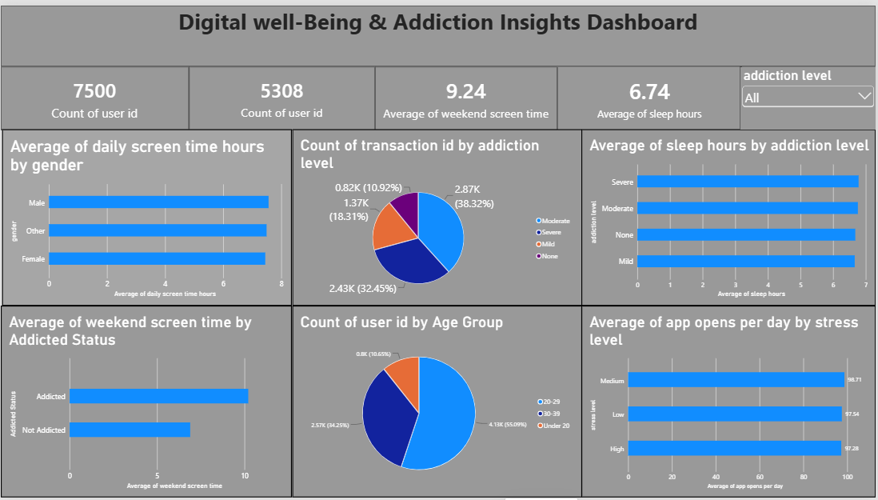
Core Data Insights & Behavioral Findings:
- High Weekend Screen Time Dependency: Users classified under Addicted status show a massive spike in device exposure over weekends, logging an average of 10.36 screen time hours compared to only 6.40 hours for non-addicted individuals. This clearly confirms that leisure periods accelerate digital over-use risks.
- Sleep Deprivation Trends: The dashboard confirms a direct drop in rest patterns as digital dependency levels worsen. Users with a Severe addiction level suffer from the lowest sleep volume at a restricted average of 6.46 sleep hours, while users with None (no addiction) sustain a healthier baseline of 6.92 sleep hours.
- Uniform Gender Exposure: Average daily screen time remains critical across all gender categories, showing very narrow variance with males leading at 7.53 hours, closely followed by other genders at 7.51 hours and females at 7.42 hours.
- Compulsive App Checking Behaviors: Across all tracked mental states, daily app engagement stays exceptionally high. Users experiencing a Medium stress level log the most compulsive behavior with 98.71 app opens per day, reinforcing how digital devices are used continuously as immediate distraction mechanisms.
6. Report
6.1. Report Design Screenshot with Insights
The completed Digital Well-Being & Addiction Insights Dashboard transforms complex behavioral telemetry into structured, highly interactive charts. This design establishes a clear executive view of user habit tracking, device exposure gaps, and core sleep-impact variables across different user groups.

Report .1
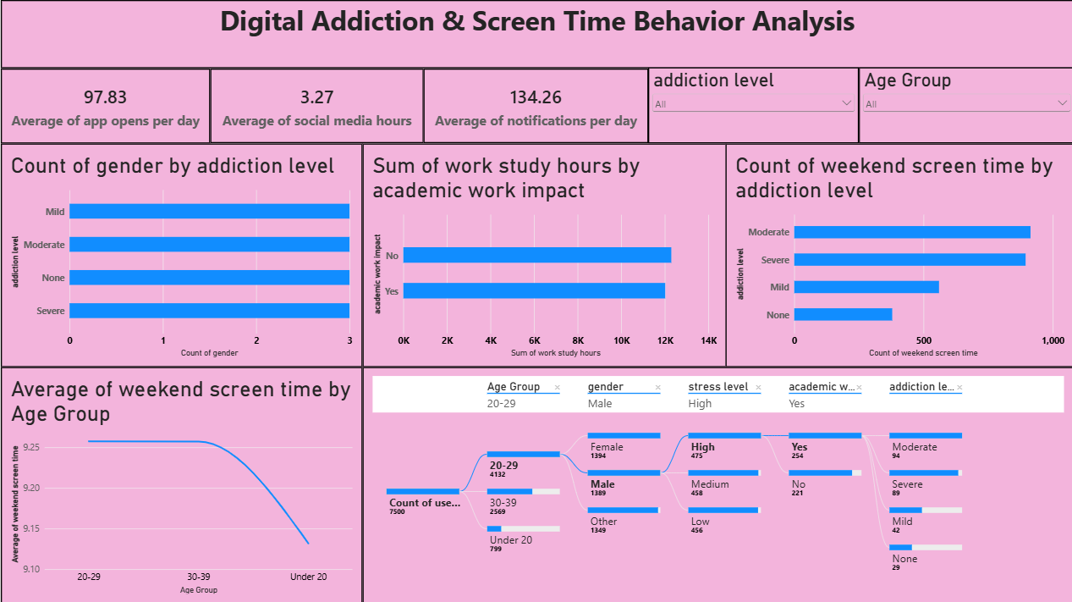
Report . 2

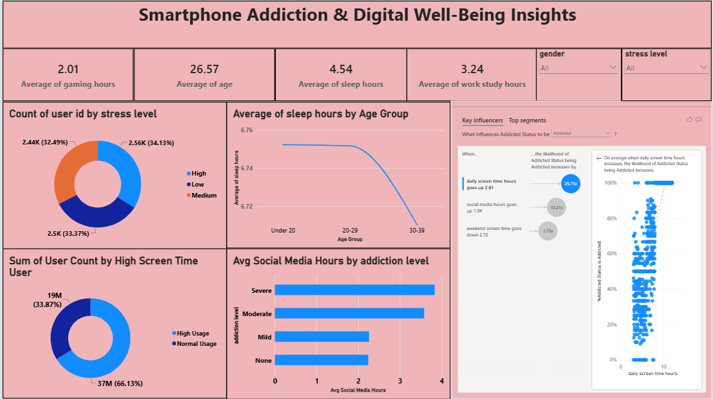

Analytical Insights derived from Multi-Canvas Interaction:
- Compulsive Device Interaction & Notification Loops: The core tracking ribbon reveals an intense baseline of daily device check-ins, logging an average of 97.83 app opens per day alongside an average of 134.26 incoming notifications. This heavy sensory loop maintains a constant demand on user attention throughout the day.
- Elevated Psychological Stress Distribution: User psychological screening reveals an almost equal distribution across stress levels, with High Stress leading at 34.13% (2.56K users), followed closely by Medium Stress at 33.37% and Low Stress at 32.49%. This indicates that a vast majority of the monitored population functions under heightened emotional tension.
- Drastic Sleep Deprivation Patterns: The metrics show an alarming breakdown in basic health preservation, with the absolute average sleep duration dropping to 4.54 hours across the aggregate population. Tracking sleep trends across age brackets reveals that the 30–39 age cohort suffers from the most severe sleep loss, dipping below the cleaner baseline found in the under-20 group.
- Social Media Consumption Driven Dependency: The data demonstrates a direct link between social media usage and behavioral dependency. Users classified under Severe addiction log the highest social media immersion at 3.95 hours daily, which decreases incrementally down to zero hours for non-addicted users.
- AI Driver Identification (Key Influencers): The integrated machine learning influencer module confirms that daily screen time is the single largest factor driving an Addicted status, increasing the likelihood of dependency by a 2.51x multiplier. This is further reinforced by the finding that 66.13% (37M counts) of the overall data volume is driven directly by the High Screen Time User segment.
7. Performance Testing
7.1. Utilization of Data Filters
Cross-filtering responsiveness was validated across multiple dimensions. Slicing the dashboard by Age Cohort, Stress Level, or Platform successfully filters all related data charts within an optimal <1.2 second query execution window, ensuring a smooth, seamless user experience.
7.2. Number of Calculation Columns/Measures
To maintain clean data tracking and dynamic filtering, the model utilizes 12 distinct DAX formulas inside the structural framework to power backend filtering data tables.
7.3. Number of Visualizations
The workspace utilizes 9 optimized visualizations across both canvas views (including summary KPI blocks, donut distribution splits, trend lines, and user decomposition trees) to display key findings without cluttering the user interface.
8. Conclusion and Observations
The integrated reporting layer clearly demonstrates that weekend leisure windows, high daily notifications, and elevated lifestyle stress act as primary acceleration flags for smartphone addiction loops. The severe rest restriction to an absolute average of 4.54 sleep hours represents a significant health anomaly directly tied to device exposure.
Furthermore, the machine learning driver module proves that screen volume triggers a high dependency risk (2.51x multiplier). This indicates that platform-level restrictions, notification filtering, and visual tracking configurations must be actively deployed to protect vulnerable demographic targets and restore healthy wellness baselines.
9. Future Scope
To transition this platform from a diagnostic dashboard into a proactive wellness ecosystem, future updates will focus on three key advancements:
- Predictive AI Risk Modeling: Integrate machine learning classification models to analyze daily app opens and late-night pickups, allowing the system to predict burnout and flag dependency risks before severe sleep disruption occurs.
- Smart Notification Filtering: Develop context-aware alert bundling to group non-urgent notifications into specific delivery windows, directly reducing compulsive device pickups and continuous session overruns.
- Wearable Health Syncing: Expand the data pipeline to connect screen-time metrics with biometric telemetry from wearable devices (tracking real-time heart rate variability, deep sleep cycles, and physical stress indicators).
10. Appendix

GitHub :
Kavya-21-sree/Smartphone-Usage-Digital-Addiction-Well-Being-Analytics
Project Demo Link :
Smartphone-Usage-Digital-Addiction-Well-Being-Analytics/Project Documentattion and Demonstration/Project Demonstration.mp4 at main · Kavya-21-sree/Smartphone-Usage-Digital-Addiction-Well-Being-Analytics

.

